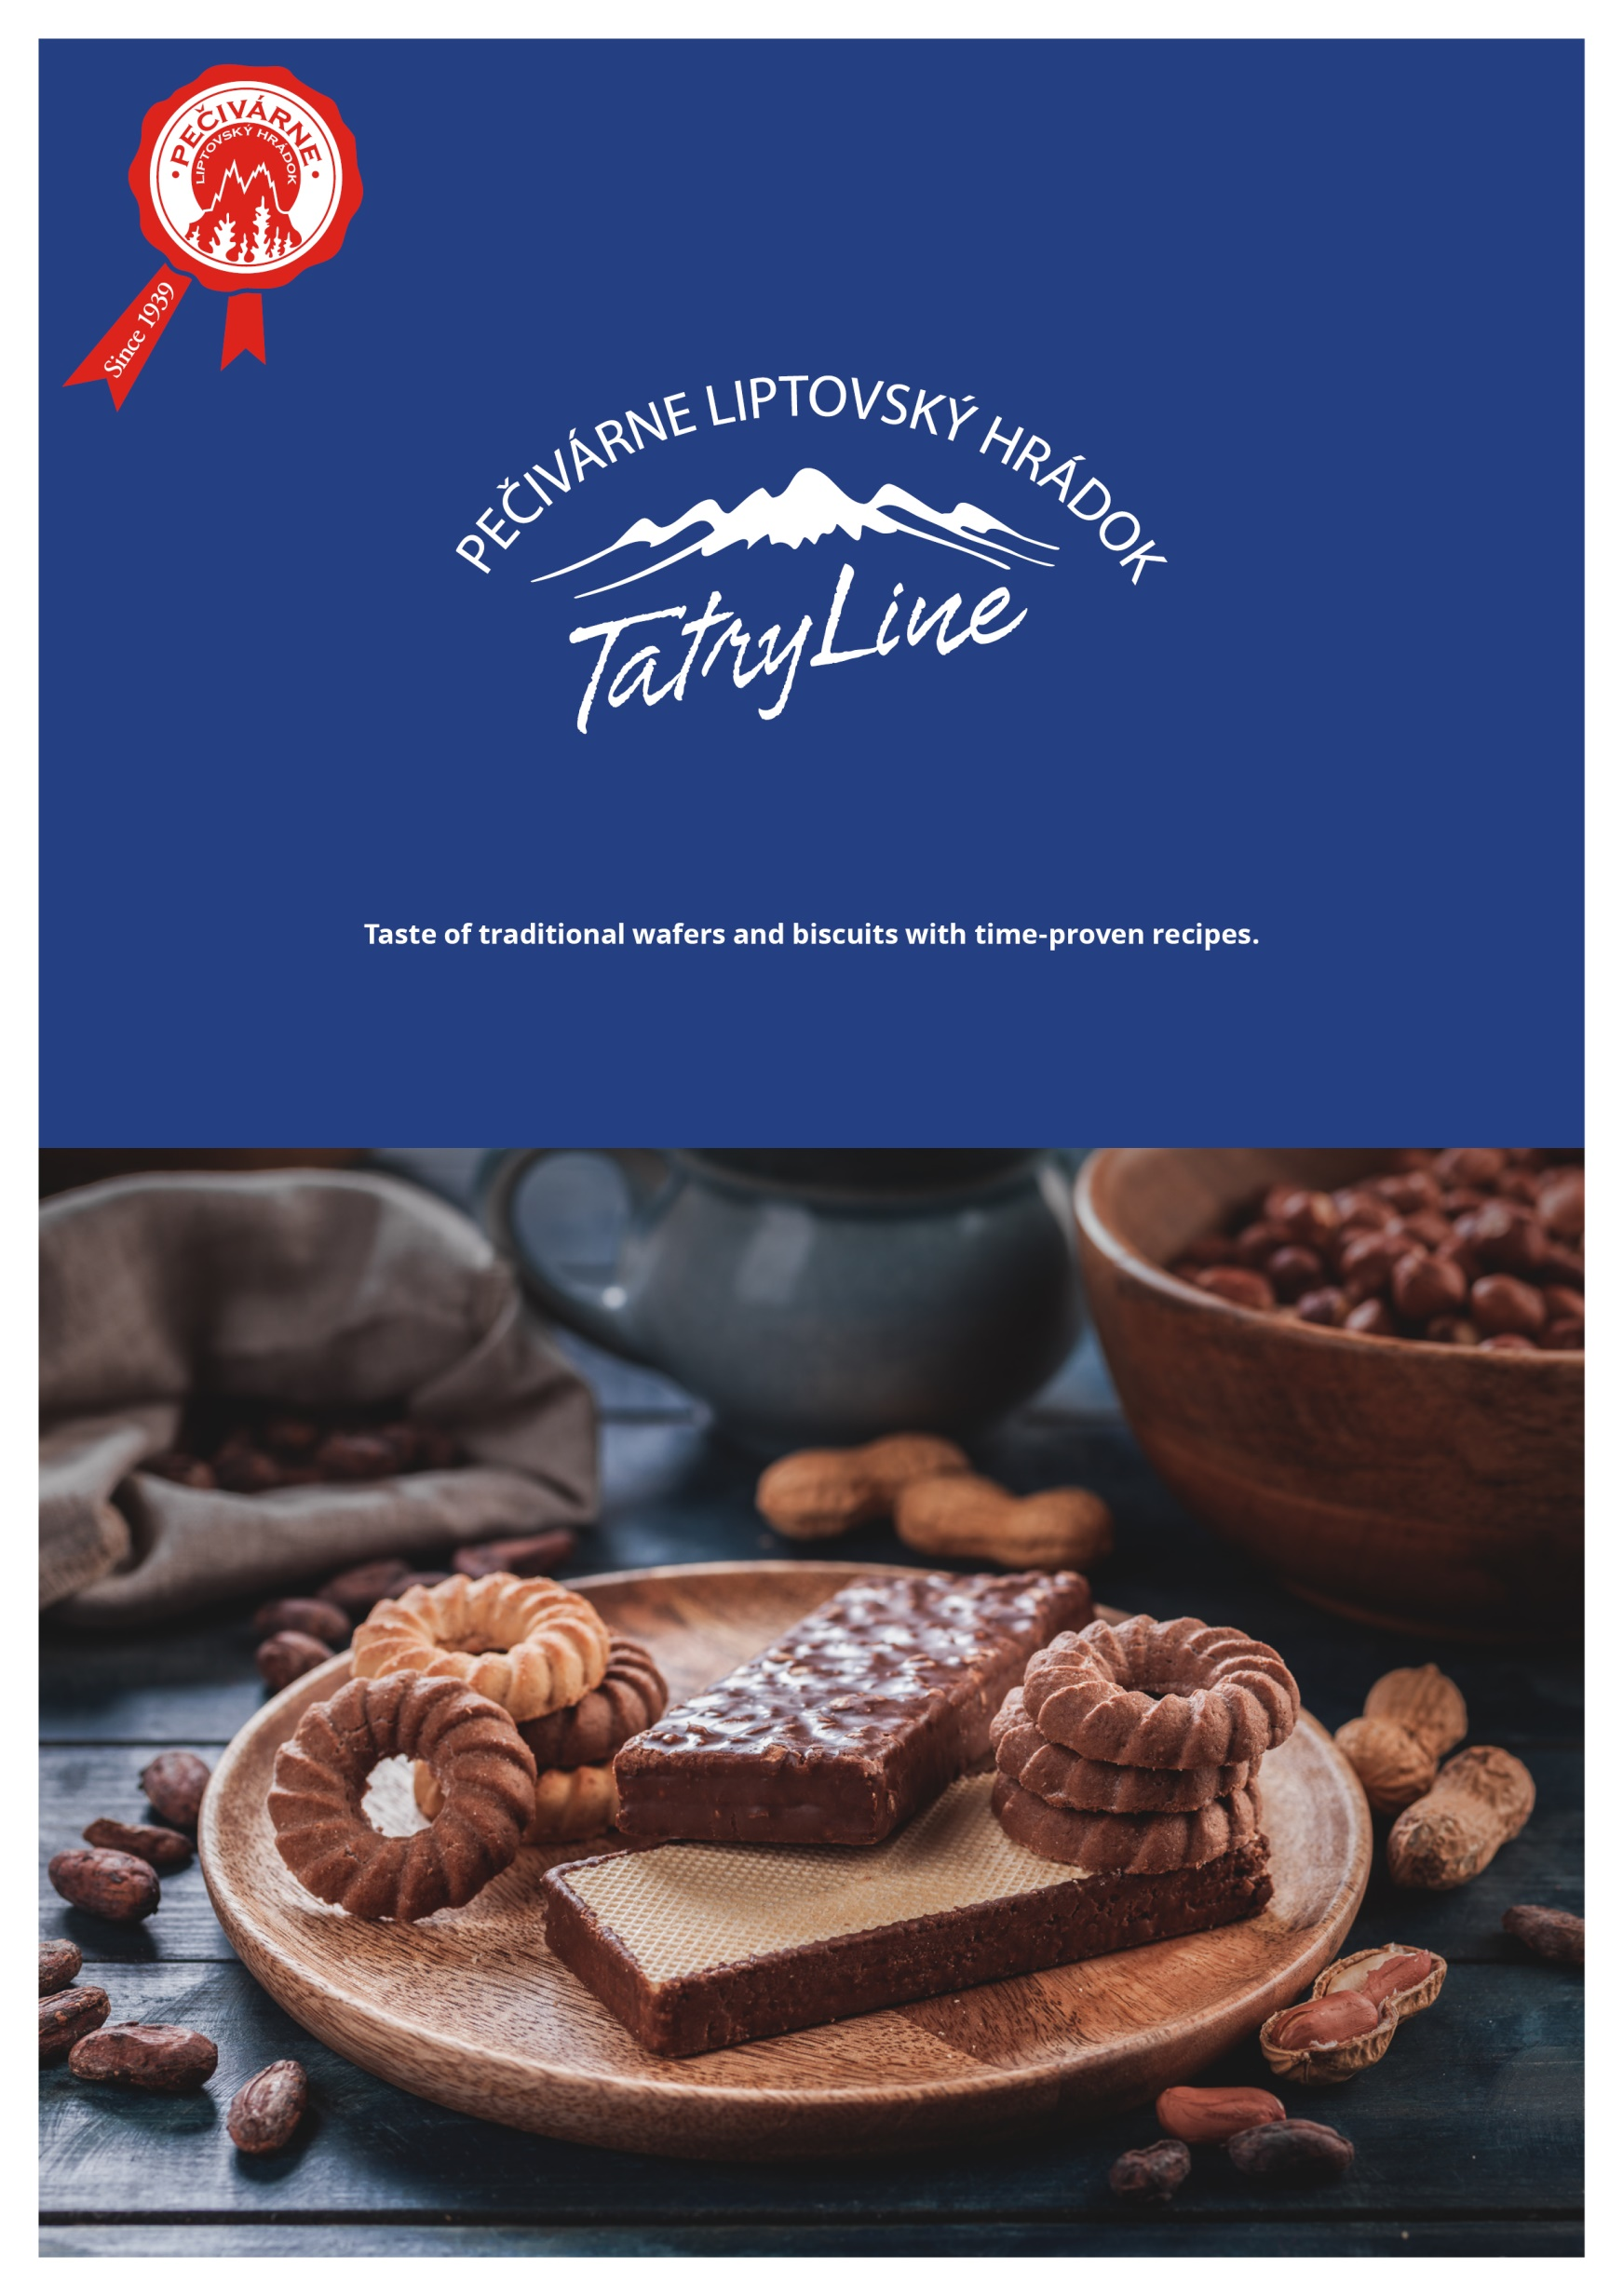

**Wafers**

[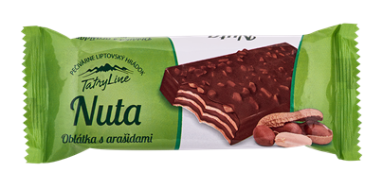](http://pecivarne.cta.sk/media/1367/tatry-line-nuta-arašid-oblátka.png)**Nuta 55 g**

vajce

**(EN) Wafer with cocoa cream filling (60 %) with peanuts, dipped in cocoa icing. Ingredients:** cocoa icing 21 % (vegetable fat /palm kernel, palm, shea/, ***whey*** powder, fat-reduced cocoa 14 %, fructose, ***lactose,*** maltodextrin, emulsifiers /lecithins, polyglycerol polyricinoleate/, flavourings), vegetable fat (palm, shea), ***wheat*** flour, sugar, roasted ***peanuts*** 12.6 %, ***soya*** flour, ***whey*** powder,skimmed ***milk*** powder, fat-reduced cocoa 2.9 %, ***wheat*** starch, flavourings, raising agents (sodium and ammonium carbonates), emulsifier (lecithins). May contain ***hazelnuts, eggs, sesame.***

Nutrition values in 100 g: Energy: 2 257 kJ/ 542 kcal; Fat: 34 g, of which saturates: 17 g; Carbohydrate: 50 g, of which sugars: 26 g; Fibre: 5.5 g; Protein: 6.2 g; Salt: 0.12 g.

**Bela 45 g**

[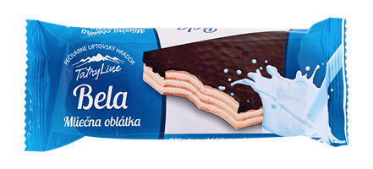](http://pecivarne.cta.sk/media/1119/tatry-line-bela-mliečna-oblátka.png)vajce  
  
**(EN) Wafer with milk cream filling (65 %) half-dipped in cocoa icing. Ingredients: *wheat*** flour, vegetable fat (palm, shea), cocoa icing 17 % (sugar, vegetable fat /palm kernel, palm, shea/, fat-reduced cocoa 14.3 %, ***whey*** powder, emulsifiers /lecithins, polyglycerol polyricinoleate/, flavourings), sugar, whole ***milk*** powder 19 % in the filling, ***whey*** powder, ***soya*** flour, flavourings, raising agents (sodium and ammonium carbonates), emulsifier (lecithins), roasted ***peanuts***. May contain ***nuts, sesame, eggs.***

Nutrition values in 100 g: Energy: 2 318 kJ/ 556 kcal; Fat: 35 g, of which saturates: 21 g; Carbohydrate: 49 g, of which sugars: 31 g; Fibre: 3.3 g; Protein: 9.6 g; Salt: 0.34 g.

**Gerlašky 35 g**

[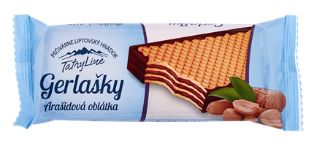](http://pecivarne.cta.sk/media/1368/tatry-line-gerlašky-arašid-polomáč-oblátka.png)vajce

**(EN)** **Wafer with peanut cream filling (63 %) dipped in cocoa icing on sides. Ingredients: *wheat*** flour, vegetable fat (palm, shea), sugar, cocoa icing 14 % (sugar, vegetable fat /palm kernel, palm, shea/, fat-reduced cocoa 14.3 %, ***whey*** powder, emulsifiers /lecithins, polyglycerol polyricinoleate/, flavourings), roasted ***peanuts*** 6.7 %, ***whey*** powder, ***soya*** flour, fat-reduced cocoa, skimmed ***milk*** powder, ***wheat*** starch, raising agents (sodium and ammonium carbonates), emulsifier (lecithins), flavouring. May contain ***nuts, sesame, eggs.***

Nutrition values in 100 g: Energy: 2 234 kJ/ 535 kcal; Fat: 31 g, of which saturates: 17 g; Carbohydrate: 55 g, of which sugars: 33 g; Fibre: 2.4 g; Protein: 8.6 g; Salt: 0.20 g.

# Kriváňky 35 g

# [Kriváňky Milk wafer](http://pecivarne.cta.sk/media/1369/tatry-line-kriváňky-mlieč-oblátka.png)vajce

**(EN) Wafer with milk cream filling (63 %) dipped in cocoa icing on sides. Ingredients: *wheat*** flour, vegetable fat (palm, shea), sugar, cocoa icing 14 % (sugar, vegetable fat /palm kernel, palm, shea/, fat-reduced cocoa 14.3 %, ***whey*** powder, emulsifiers /lecithins, polyglycerol polyricinoleate/, flavourings), ***whey*** powder, skimmed ***milk*** powder 2.4 %, ***soya*** flour, flavourings, raising agents (sodium and ammonium carbonates), emulsifier (lecithins), roasted ***peanuts***. May contain ***nuts, sesame, eggs.***

Nutrition values in 100 g: Energy: 2 277 kJ/ 546 kcal; Fat: 32 g, of which saturates: 19 g; Carbohydrate: 56 g, of which sugars: 36 g; Fibre: 3.2 g; Protein: 5.9 g; Salt: 0.21 g.

**Belanky 35 g**

[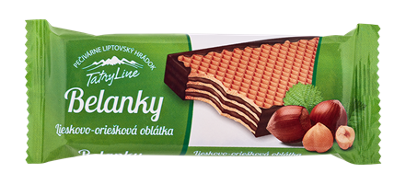](http://pecivarne.cta.sk/media/1120/tatry-line-belanky-liesk-oriešk-oblátka.png)

vajce

**(EN) Wafer with hazelnut cream filling (63 %) dipped in cocoa icing on sides. Ingredients: *wheat*** flour, sugar, vegetable fat (palm, shea), cocoa icing 14 % (sugar, vegetable fat /palm kernel, palm, shea/, fat-reduced cocoa 14.3 %, ***whey*** powder, emulsifiers /lecithins, polyglycerol polyricinoleate/, flavourings), vegetable oil (rapeseed), ***whey*** powder, ***soya*** flour, roasted ***hazelnuts*** 2.3% in the filling, fat-reduced cocoa, maize starch, flavourings, raising agents (sodium and ammonium carbonates), emulsifier (lecithin), roasted ***peanuts***. May contain ***nuts, eggs, sesame.***

Nutrition values in 100 g: Energy: 2 245 kJ/ 538 kcal; Fat: 32 g, of which saturates: 15 g; Carbohydrate: 54 g, of which sugars: 31 g; Protein: 6.3 g; Salt: 0.22 g.

**Cocoa wafers 40 g**

[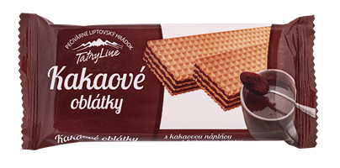](http://pecivarne.cta.sk/media/1370/tatry-line-kakaové-oblátky.png)

vajce

**(EN) Wafers with cocoa cream filling (75 %). Ingredients: *wheat*** flour, vegetable fat (palm, shea), sugar, fat-reduced cocoa 9 %, ***whey*** powder, skimmed ***milk*** powder, ***wheat*** starch, raising agents (sodium and ammonium carbonates), flavouring, emulsifier (lecithins), roasted ***peanut***. May contain ***nuts, sesame, eggs*** and ***soya.***

Nutrition values in 100 g: Energy: 2 193 kJ/ 525 kcal; Fat: 30 g, of which saturates: 18 g; Carbohydrate: 54 g, of which sugars: 31 g; Fibre: 4.5 g; Protein: 7.6 g; Salt: 0.25 g.

[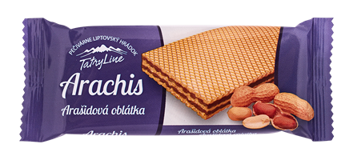](http://pecivarne.cta.sk/media/1118/tatry-line-arachis-arašid-oblátka.png)**Arachis 25 g**

vajce

**(EN) Wafer with peanut cream filling (76 %). Ingredients: *wheat*** flour, vegetable fat (palm, shea), sugar, roasted ***peanuts*** 8 %, ***whey*** powder***, soya*** flour, fat-reduced cocoa, skimmed ***milk*** powder, ***wheat*** starch, raising agents (sodium and ammonium carbonates), emulsifier (lecithins), flavouring. May contain ***nuts, sesame, eggs.***

Nutrition values in 100 g: Energy: 2 251 kJ/ 540 kcal; Fat: 33 g, of which saturates: 21 g; Carbohydrate: 50 g, of which sugars: 28 g; Fibre: 5.3 g; Protein: 8.6 g; Salt: 0.06 g.

**B****runis 25 g**

[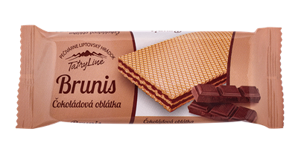](http://pecivarne.cta.sk/media/1371/tatry-line-brunis-čok-oblátka.png)vajce

**(EN) Wafer with chocolate cream filling (76 %). Ingredients: *wheat*** flour, sugar, vegetable fat (palm, shea), fat-reduced cocoa powder 7.2 %, chocolate 3.3 % (sugar, cocoa mass, cocoa butter, ***milk*** fat, emulsifiers /***soya*** lecithin, polyglycerol polyricinoleate/, vanilla extract), ***whey*** powder, skimmed ***milk*** powder, raising agents (sodium and ammonium carbonates), flavourings, emulsifier (lecithins). May contain ***peanuts, nuts, sesame*** and ***eggs.***

Nutrition values in 100 g: Energy: 2 122 kJ/ 508 kcal; Fat: 26 g, of which saturates: 15 g; Carbohydrate: 60 g, of which sugars: 31 g; Fibre: 6.6 g; Protein: 5.1 g; Salt: 0.15 g.

**Biscuits**

**Egg rings 100 g**

[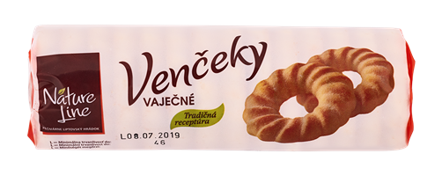](http://pecivarne.cta.sk/media/1372/nature-line-venčeky-vaječné.png)

**(EN) Egg ring biscuits coated in sugar (7 %).  Ingredients:** ***wheat*** flour, sugar, margarine (vegetable palm fats, vegetable rapeseed oil, water, emulsifiers /mono- and diglycerides of fatty acids, lecithins/, salt, preservative /sorbic acid/, acidity regulator /citric acid/), ***whey*** powder, ***egg*** yolk powder 2.2 %, skimmed ***milk*** powder, raising agent (ammonium carbonates), flavourings. May contain ***peanuts, nuts, soya, sesame***.

Nutrition values in 100 g: Energy: 1 981 kJ/ 473 kcal; Fat: 20 g, of which saturates: 6 g; Carbohydrate: 64 g, of which sugars: 25 g; Fibre: 2 g; Protein: 8.8 g; Salt: 0.11 g.

[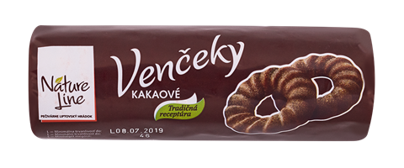](http://pecivarne.cta.sk/media/1373/nature-line-venčeky-kakao.png)**Cocoa rings 100 g**

**(EN) Cocoa ring biscuits coated in sugar (7 %).  Ingredients:** ***wheat*** flour, vegetable fat (vegetable palm fats, vegetable rapeseed oil, emulsifiers /mono- and diglycerides of fatty acids, lecithins/, preservative /sorbic acid/, acidity regulator /citric acid/), sugar, ***wheat*** starch, fat-reduced cocoa 3.9 %, grated coconut, ***whey*** powder, powdered ***egg*** mix, skimmed ***milk*** powder, raising agent (ammonium carbonates), flavouring. May contain ***peanuts, nuts, sesame*** and ***soya***.

Nutrition values in 100 g: Energy: 2 025 kJ/ 484 kcal; Fat: 23 g, of which saturates: 9 g; Carbohydrate: 59 g, of which sugars: 20 g; Fibre: 4 g; Protein: 8 g; Salt: 0.11 g.

**Peanut rings 100 g**

[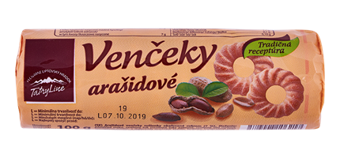](http://pecivarne.cta.sk/media/1397/tatry-line-venčeky-arašid.png)

**(EN) Peanut ring biscuits coated in sugar (7 %).  Ingredients:** ***wheat*** flour, vegetable fat (vegetable palm fats, vegetable rapeseed oil, emulsifiers /mono- and diglycerides of fatty acids, lecithins/, preservative /sorbic acid/, acidity regulator /citric acid/), sugar, maize starch, ***whey*** powder, roasted ***peanuts*** 3 %, powdered ***egg*** mix, colour (plain caramel), flavouring, raising agent (ammonium carbonates), skimmed ***milk*** powder, cinnamon powder. May contain ***nuts, soya*** and ***sesame***.

Nutrition values in 100 g: Energy: 2 037 kJ/ 486 kcal; Fat: 21 g, of which saturates: 7 g; Carbohydrate: 65 g, of which sugars: 25 g; Fibre: 1.7 g; Protein: 8.1 g; Salt: 0.10 g.

**Coconut rings 100 g**

[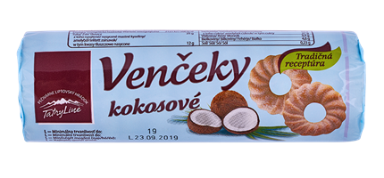](http://pecivarne.cta.sk/media/1398/tatry-line-venčeky-kokosové.png)

**(EN) Coconut ring biscuits coated in sugar (7 %).  Ingredients:** ***wheat*** flour, vegetable fat (vegetable palm fats, vegetable rapeseed oil, emulsifiers /mono- and diglycerides of fatty acids, lecithins/, preservative /sorbic acid/, acidity regulator /citric acid/), sugar, grated coconut5 %*,* ***wheat*** starch, ***whey*** powder, ***soya*** flour, powdered ***egg*** mix, ***egg*** yolk powder, skimmed ***milk*** powder, flavourings. May contain ***peanuts, nuts*** and ***sesame***.

Nutrition values in 100 g: Energy: 2 121 kJ/ 506 kcal; Fat: 25 g, of which saturates: 12 g; Carbohydrate: 64 g, of which sugars: 27 g; Fibre: 3.9 g; Protein: 4.6 g; Salt: 0.23 g.

**Biscuits half - dipped in cocoa icing 90 g**

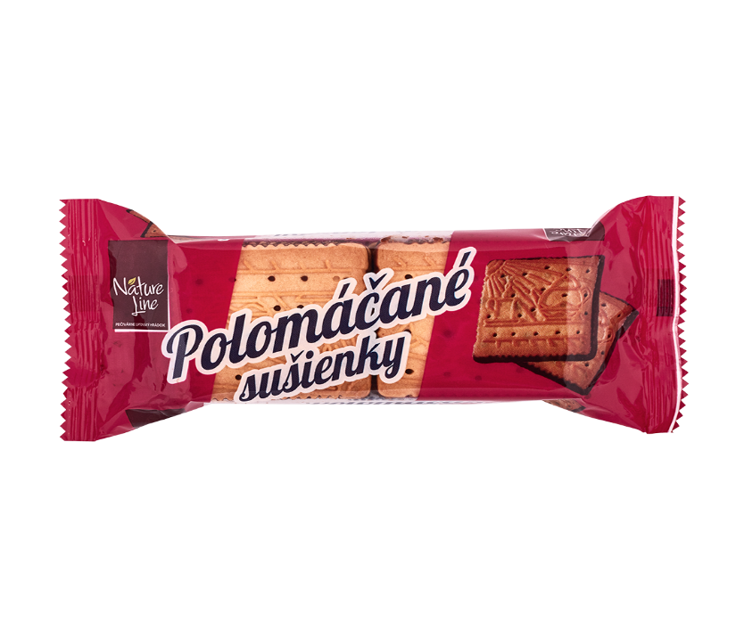

**(EN) Biscuits half-dipped in cocoa icing.  Ingredients:** ***wheat*** flour, cocoa icing 20 % (sugar, vegetable fat /palm kernel, palm, shea/, fat-reduced cocoa 14.3 %, ***whey*** powder, emulsifiers /lecithins, polyglycerol polyricinoleate/, flavourings), vegetable fat (vegetable palm fats, vegetable rapeseed oil, emulsifiers /mono- and diglycerides of fatty acids, lecithins/, preservative /sorbic acid/, acidity regulator /citric acid/), sugar, glucose syrup, ***egg*** yolk powder, raising agents (ammonium and sodium carbonates), flavourings. May contain ***peanuts, nuts, sesame*** and ***soya***.

Nutrition values in 100 g: Energy: 2 112 kJ/ 504 kcal; Fat: 23 g, of which saturates: 11 g; Carbohydrate: 66 g, of which sugars: 28 g; Fibre: 2 g; Protein: 7 g; Salt: 0.11 g.

**Coconut biscuit mix 200 g**

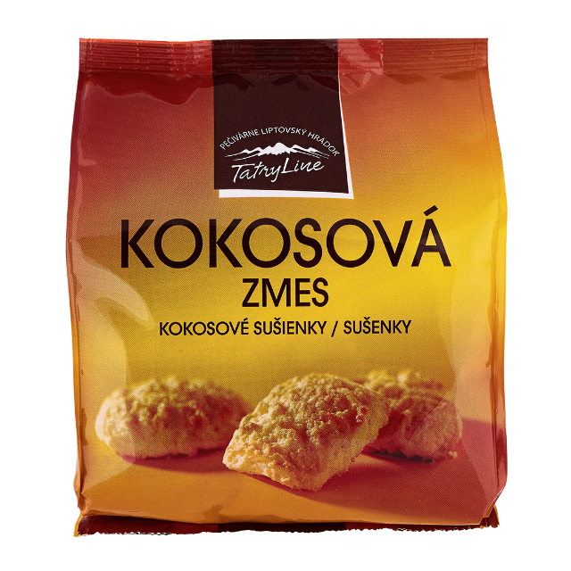

**(EN) Coconut biscuits.  Ingredients:** ***wheat*** flour, sugar, vegetable fat (vegetable palm fats, vegetable rapeseed oil, emulsifiers /mono- and diglycerides of fatty acids, lecithins/, preservative /sorbic acid/, acidity regulator /citric acid/), grated coconut9.8 %*,*maize starch, ***whey*** powder, skimmed ***milk*** powder, powdered ***egg*** mix, raising agents (sodium and ammonium carbonates), salt. May contain ***peanuts, nuts soya*** and ***sesame***.

Nutrition values in 100 g: Energy: 2 049 kJ/ 489 kcal; Fat: 23 g, of which saturates: 11 g; Carbohydrate: 63 g, of which sugars: 24 g; Fibre: 2 g; Protein: 6.6 g; Salt: 0.32 g.

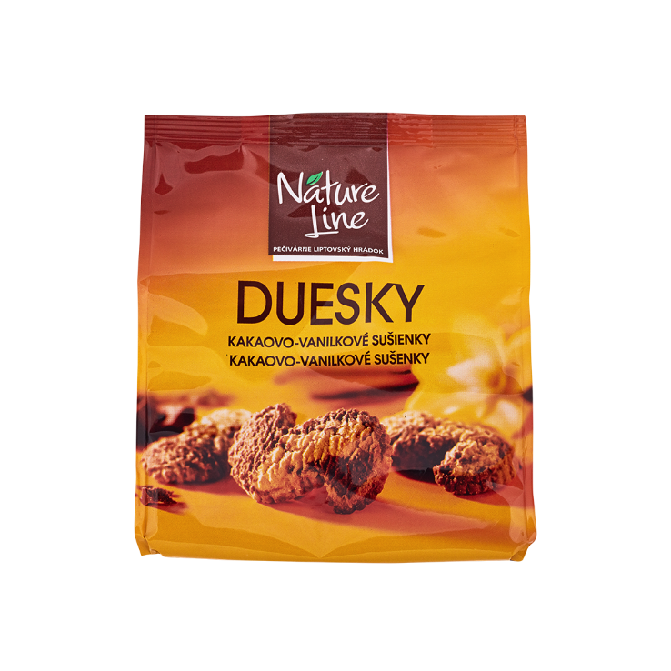**Duesky 200 g**

bezlaktozy

**(EN) Biscuits with cocoa and natural vanilla flavouring. Ingredients:** ***wheat*** flour, vegetable fat (vegetable palm fats, vegetable rapeseed oil, emulsifiers /mono- and diglycerides of fatty acids, lecithins/, preservative /sorbic acid/, acidity regulator /citric acid/), sugar, maize starch, fat-reduced cocoa 1 %, ***egg*** yolk powder, flavouring, cinnamon powder, natural vanilla flavouring. May contain ***peanuts, nuts, milk, soya*** and ***sesame***.

Nutrition values in 100 g: Energy: 2 075 kJ/ 495 kcal; Fat: 23 g, of which saturates: 8 g; Carbohydrate: 63 g, of which sugars: 20 g; Fibre: 2.7 g; Protein: 6.6 g; Salt: 0.09 g.

**Coatings**

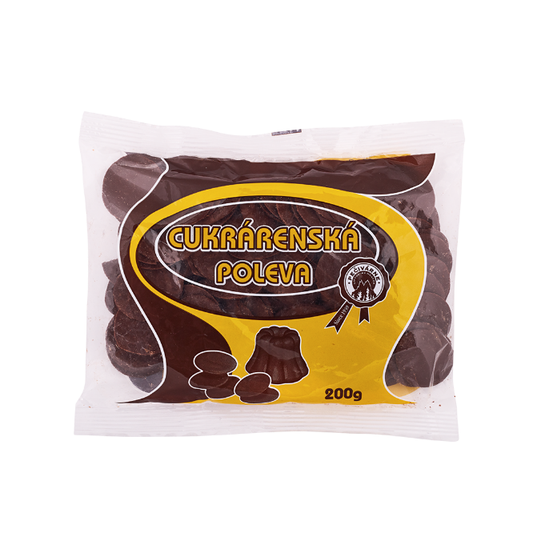**Cocoa coating 500g/200g**

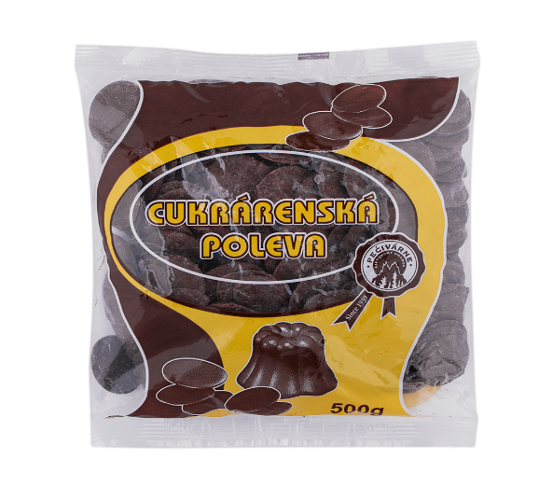

vajceklas

**(EN) Confectionery cocoa coating. Ingredients**: sugar, vegetable fat (palm kernel, palm, shea), fat-reduced cocoa 14.3 %, **whey** powder, emulsifier (lecithins, polyglycerolpolyricinoleate), flavourings. May contain ***peanuts, nuts, soya, sesame*** *and* ***eggs***. Keep in a dry place, away from heat.

Nutritional values in 100 g: Energy: 2333kJ/560 kcal; Fat: 36 g, of which saturates: 33g; Carbohydrate: 52 g, of which sugars: 52 g; Fibre: 5.7 g; Protein: 4.2 g; Salt: 0.12 g

**Directions for use**: Melt the cocoa icing in a bowl placed over boiling water and use it for decoration of cakes, pancakes etc. The gray coating on the surface is not a defect.   
  
The product contains: milk.

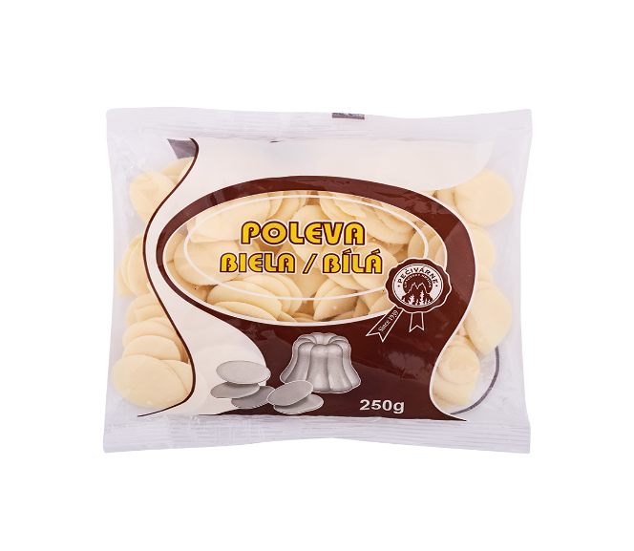**White coating 250 g**

vajceklas

**(EN) White confectionery coating. Ingredients**: sugar, vegetable fat (palm kernel, palm, shea), whey powder, emulsifiers (lecithins, polyglycerolpolyricineoleate), flavourings. May contain peanuts, nuts, soya, sesame and eggs. Keep in a dry place, away from heat.

Nutritional values in 100 g: Energy: 2346 kJ/560 kcal; Fat: 35 g, of which saturates 31 g; Carbohydrate: 58 g, of which sugars: 52 g; Fibre: 0.7 g; Protein: 2.3 g, Salt: 0.33 g

**Directions for use:** Melt the white icing in a bowl placed over boiling water and use it for decoration of cakes, pancakes etc.   
  
The product contains: milk

**Annotation**

|  |  |
| --- | --- |
| bezlaktozy | Milk free product |
| hrozno | Sugar free product |
| klas | Gluten free product |
| vajce | Egg free product |
| rutin | Rutin |
| kyselina listova | Folic acid |